

Chittagong University of Engineering and Technology

Department of Electrical and Electronic Engineering

PROJECT SUBMIS SION REPORT

Course No.: EEE 242

Course Title: Electronic Shop Practice

Project name: Arduino Based Fire Fighting Robot

Submitted by: -

|  |  |
| --- | --- |
| **Name** | **ID** |
| Kazi Rayhan Shihab | 17 02 052 |
| Faysal Mehedi Rahman | 17 02 055 |
| Moinul Hossain | 17 02 057 |
| Rashedul Islam | 17 02 064 |

Date of submission: 28 / 1 1 / 2 0 1 9

**TABLE OF CONTENT**

|  |  |
| --- | --- |
| Content | Page No. |
| Introduction | 02 |
| Equipment | 02 |
| Equipment Description | 03 |
| Cost Estimation | 05 |
| Circuit Diagram | 05 |
| Working Principle | 06 |
| Code | 07 |
| Description of Construction | 12 |
| Discussion & Conclusion | 12 |
| Reference | 12 |

Introduction:

A many people die every year due to Fire accidents. Even though there are a lot of precautions taken for Fire accidents, these natural/man-made disasters do occur now and then. In the event of a fire breakout, to rescue people and to put out the fire we are forced to use human resources which are not safe. With the advancement of technology especially in Robotics it is very much possible to replace humans with robots for fighting the fire. This would improve the efficiency of firefighters and would also prevent them from risking human lives. We made a simple model of Fire Fighting Robot using Arduino, which will automatically sense the fire and start the water pump and put out fire. In this project we build a simple robot using Arduino that could move towards the fire and pump out water around it to put down the fire. It is a very simple robot that would teach us the underlying concept of robotics.

Equipment:

1. Arduino UNO
2. Fire sensor or Flame sensor
3. Servo Motor (SG90)
4. L293D motor Driver module
5. Small Breadboard
6. Robot chassis with motors and wheel
7. A small can
8. Connecting wires
9. Water pump (5v)
10. Battery

Equipment Description:

1. Arduino UNO:

Arduino Uno is a microcontroller board based on the ATmega328P (datasheet). It has 14 digital input/output pins (of which 6 can be used as PWM outputs), 6 analog inputs, a 16 MHz quartz crystal, a USB connection, a power jack, an ICSP header and a reset button. It contains everything needed to support the microcontroller; simply connect it to a computer with a USB cable or power it with an AC-to-DC adapter or battery to get started.

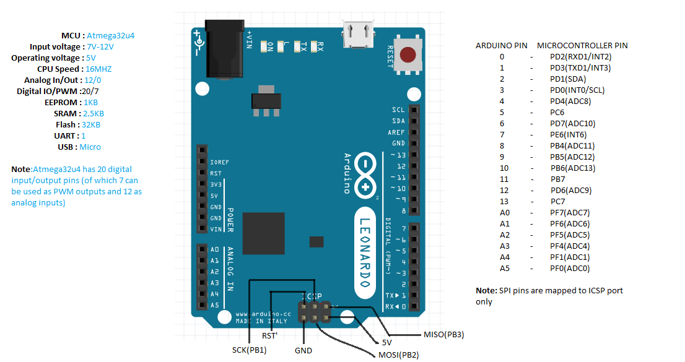

Fig. 1: Arduino UNO with pin diagram

2. Flame sensor:

A flame-sensor is one kind of detector which is mainly designed for detecting as well as responding to the occurrence of a fire or flame.

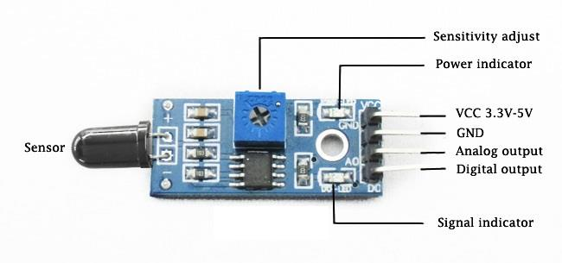

Fig. 2: Flame sensor module with pin diagram

3. Servo motor (SG90):

A servomotor is a rotary actuator or linear actuator that allows for precise control of angular or linear position, velocity and acceleration.

SG-90 Features: Operating Voltage is +5V typically, Torque: 2.5kg/cm, Operating speed is 0.1s/60°, Gear Type: Plastic, Rotation: 0°-180°, Weight of motor: 9gm, Package includes gear horns and screws.

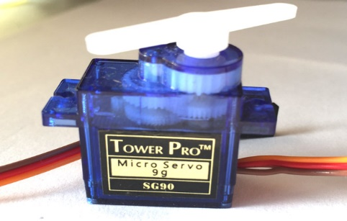

Fig. 3: SG-90 Servo Motor

4. L293D motor Driver module:

The L293D device is quadruple high-current half-H driver. The 293D is designed to provide bidirectional drive current up to 600mA a voltage from 5V to 36V. L293D Adapter Board can be used as dual DC motor driver or bipolar stepper motor driver. Useful in robotics application, bidirectional DC motor controller and stepper motor driver.

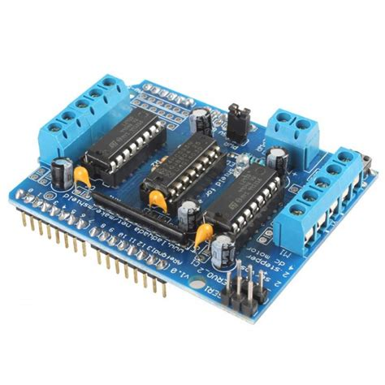

Fig. 4: L293D motor driver module

Cost Estimation:

|  |  |  |
| --- | --- | --- |
| Component | Quantity | Cost (taka) |
| Arduino UNO | 1 | 400 |
| Flame Sensor | 3 | 350 |
| Servo Motor (SG90) | 1 | 150 |
| L293D motor driver module | 1 | 250 |
| Water pump (5V) | 1 | 150 |
| Battery (lipo 2200 mAh) | 1 | 1550 |
| Breadboard (small) | 1 | 60 |
| Robot Chassis |  | 100 |
| Motor | 2 | 200 |
| Wheel | 2 | 120 |
| Ball caster | 1 | 50 |
| Other |  | 200 |
| Total Cost |  | 3580 taka |

Circuit Diagram:

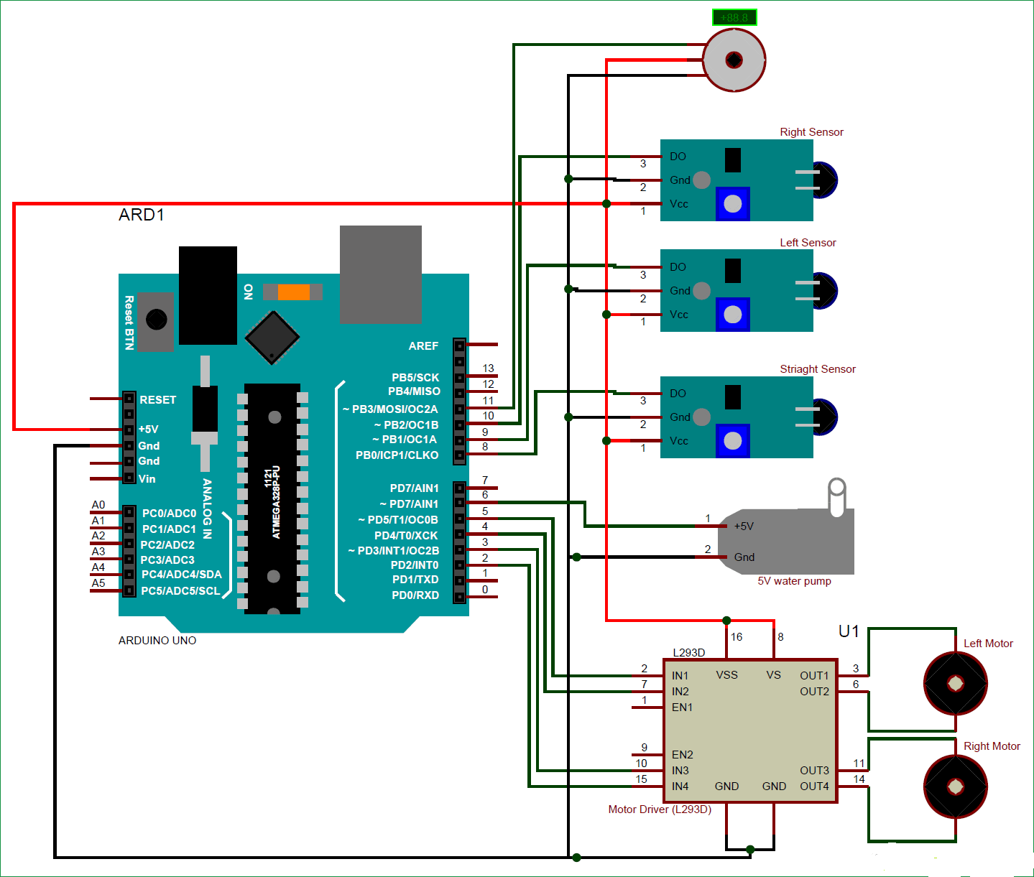

Fig. 5: Circuit Diagram for firefighting robot

Working Principle:

The main brain of this project is the Arduino, but in-order to sense fire we use the Fire sensor module (flame sensor). These sensors have an IR Receiver (Photodiode) which is used to detect the fire. When fire burns it emits a small amount of Infra-red light, this light will be received by the IR receiver on the sensor module. Then we use an Op-Amp to check for change in voltage across the IR Receiver, so that if a fire is detected the output pin (DO) will give 0V(LOW) and if the is no fire the output pin will be 5V(HIGH).

So, we place three such sensors in three directions of the robot to sense on which direction the fire is burning.

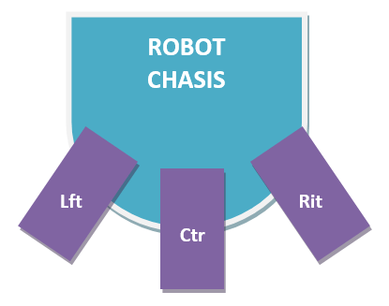

We detect the direction of the fire we can use the motors to move near the fire by driving our motors through the L293D module. When near a fire we have to put it out using water. Using a small container, we can carry water, a 5V pump is also placed in the container and the whole container is placed on top of a servo motor so that we can control the direction in which the water has to be sprayed.

Code:

#include <Servo.h>

Servo myservo;

int pos = 0;

boolean fire = false;

/*-------defining Inputs------*/

#define Left_S 9 // left sensor

#define Right_S 10 // right sensor

#define Forward_S 8 //forward sensor

/*-------defining Outputs------*/

#define LM1 2 // left motor

#define LM2 3 // left motor

#define RM1 4 // right motor

#define RM2 5 // right motor

#define pump 7

//#define ENA 10

//#define ENB 11

void setup()

{

pinMode(Left_S, INPUT);

pinMode(Right_S, INPUT);

pinMode(Forward_S, INPUT);

pinMode(LM1, OUTPUT);

pinMode(LM2, OUTPUT);

pinMode(RM1, OUTPUT);

pinMode(RM2, OUTPUT);

pinMode(pump, OUTPUT);

// pinMode(ENA, OUTPUT);

//pinMode(ENB, OUTPUT);

myservo.attach(11);

myservo.write(90);

}

void put_off_fire()

{

delay (500);

digitalWrite(LM1, LOW);

digitalWrite(RM1, LOW);

digitalWrite(LM2, LOW);

digitalWrite(RM2, LOW);

digitalWrite(pump, HIGH); delay(500);

for (pos = 50; pos <= 130; pos += 1) {

myservo.write(pos);

delay(10);

}

for (pos = 130; pos >= 50; pos -= 1) {

myservo.write(pos);

delay(10);

}

digitalWrite(pump,LOW);

myservo.write(90);

fire=false;

}

void loop()

{

myservo.write(90); //Sweep_Servo();

if (digitalRead(Left_S) ==1 && digitalRead(Right_S) ==1 && digitalRead(Forward_S) ==1) //If Fire not detected all sensors are zero

{

//Do not move the robot

digitalWrite(LM1, LOW);

digitalWrite(LM2, LOW);

digitalWrite(RM1, LOW);

digitalWrite(RM2, LOW);

}

else if (digitalRead(Forward_S) ==0) //If Fire is straight ahead

{

//Move the robot forward

digitalWrite(LM1, HIGH);

digitalWrite(LM2, LOW);

digitalWrite(RM1, LOW);

digitalWrite(RM2, HIGH);

digitalWrite(pump, HIGH);

fire = true;

}

else if (digitalRead(Left_S) ==0) //If Fire is to the left

{

//Move the robot left

digitalWrite(LM1, LOW);

digitalWrite(LM2, LOW);

digitalWrite(RM1, LOW);

digitalWrite(RM2, HIGH);

} else if (digitalRead(Right_S) ==0) //If Fire is to the right

{

//Move the robot right

digitalWrite(LM1, HIGH);

digitalWrite(LM2, LOW);

digitalWrite(RM1, LOW);

digitalWrite(RM2, LOW);

}

delay(300); //Slow down the speed of robot

while (fire == true)

{

put_off_fire();

}

}

Description of Construction:

1.First we bought the equipment’s from the store.

2. Then we made our design of the robot.

3. Then We connected the flame sensors to the Arduino UNO as inputs. These flame sensors collect the IR ray from fire and give signals to the servo motor to rotate and to the pump.

4. We connected the motors in motor driver as outputs. When the sensors get IR ray the motors start to rotate towards the fire.

5. After giving connection properly we give code to the Arduino according to our pins.

6. Finally we checked our robot by bringing a fire in front of it and saw the result.

Discussion & Conclusion:

We made a simple model of Fire Fighting Robot using Arduino, which will automatically sense the fire and start the water pump and put out fire. It is a simple and low budget model. We can further improve this project for live feedback of the scene. We can also add manual remote controlling beside automatic sensing which will improve its workability.

Reference:

1. GitHub link: <https://github.com/mhr958/fire-fighting-robot>